**FABIEN CHANGES AND BUG LIST 2**

1. **Show all br tags for description of profile ( profile page and lists of profiles )**

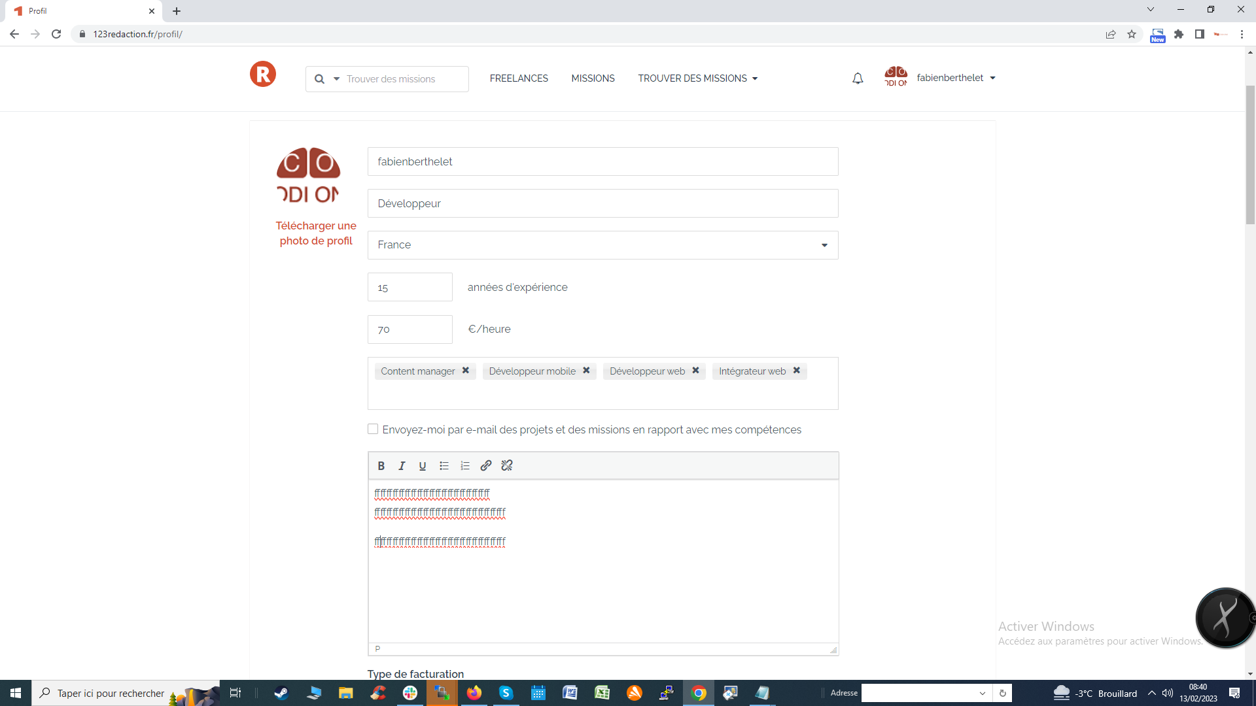

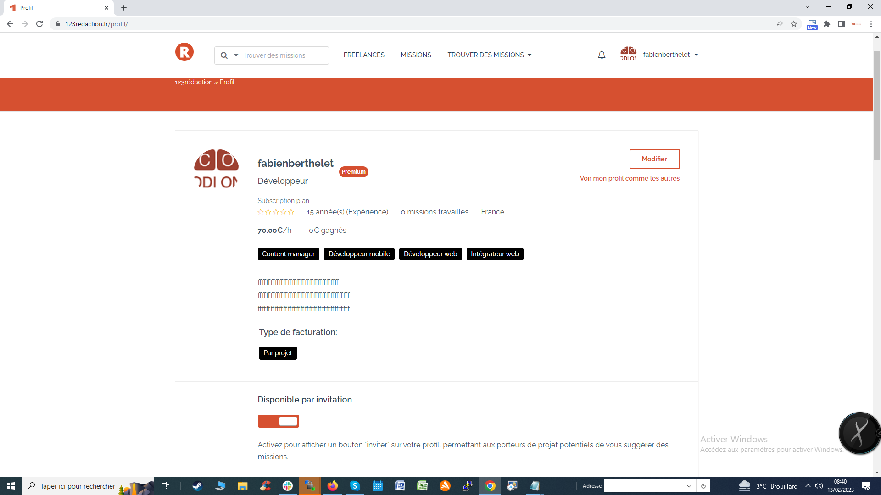

1. **Fix X close buttons for all modals**

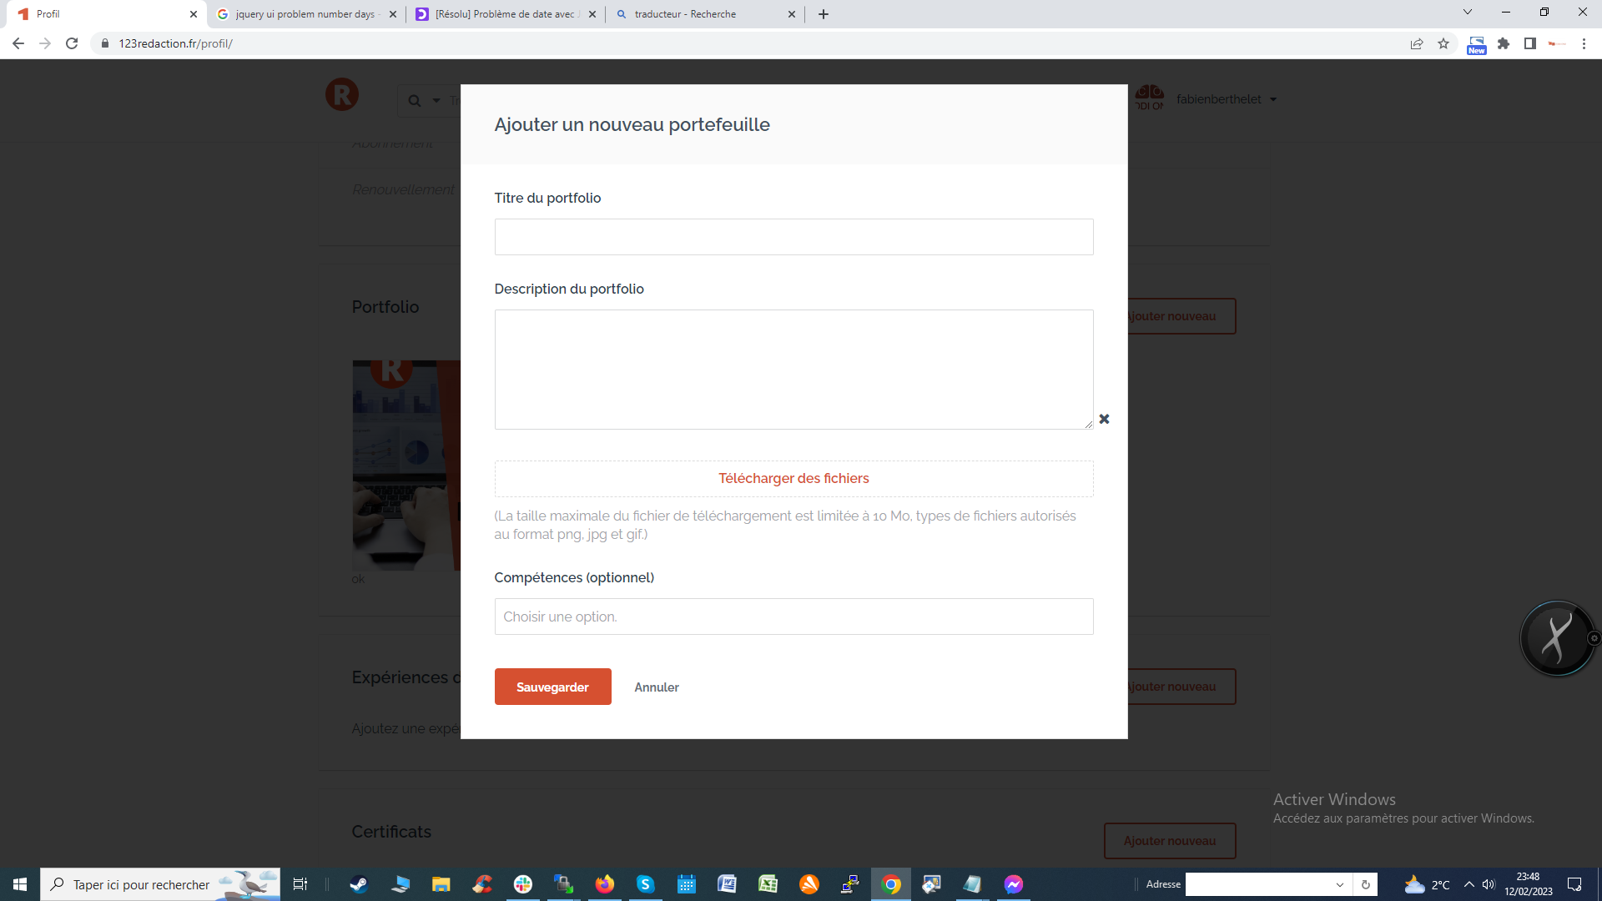

1. **Change CSS for buttons modifier and remove ( portfolio )**

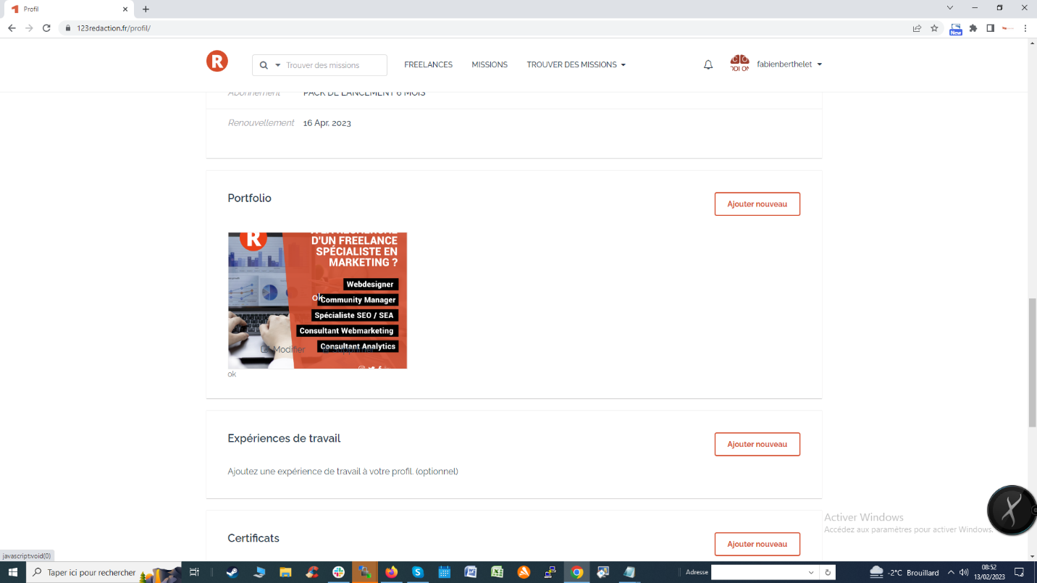

You have to change the css with a background-color: #db482c; color: #ffffff; padding: 3px;